**Institute of Information Technology (IIT)**

Jahangirnagar University



**Lab Report: 03**

**Course Code: ICT-4104**

Submitted by:

Name: Md. Shakil Hossain

Roll No: 2023

Lab Date: 10-Jul-2023 Submission Date: 31-Jul-23

## EXP.NO: 03

NAME OF EXPERIMENT: TO FIND DFT / IDFT OF GIVEN DT SIGNAL

AIM: To find Discrete Fourier Transform and Inverse Discrete Fourier Transform of given digital signal.

Software: MATLAB

THEORY: Discrete Fourier transform (DFT) converts a finite sequence of equally-spaced samples of a function into a same-length sequence of equally-spaced samples of the discrete- time Fourier transform (DTFT), which is a complex-valued function of frequency. An inverse DFT (IDFT) is a Fourier series, using the DTFT samples as coefficients of complex sinusoids at the corresponding DTFT frequencies. It has the same sample-values as the original input sequence. The DFT is therefore said to be a frequency domain representation of the original input sequence.

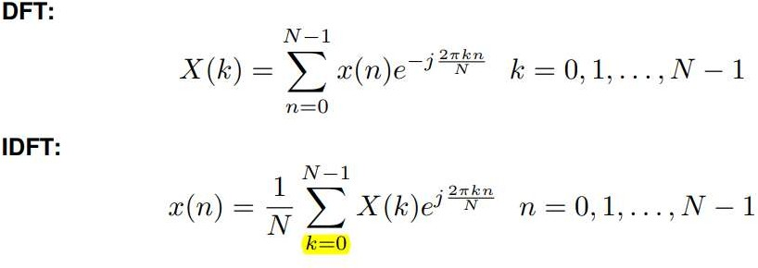

## METHODOLOGY

Algorithm:

Step I: Get the input sequence.

Step II: Find the DFT of the input sequence using the direct equation of DFT.

Step III: Find the IDFT using the direct equation.

Step IV: Plot DFT and IDFT of the given sequence using Matlab command stem.

Step V: Display the above outputs.

## PROGRAM:

clc;

clear;

close all;

xn=input('Enter the sequence x(n)'); %Get the sequence from user

ln=length(xn); %find the length of the sequence

xk=zeros(1,ln); %initialize an array of same size as that of input sequence

ixk=zeros(1,ln); %initialize an array of same size as that of input sequence

%DFT of the sequence

for k=0:ln-1

for n=0:ln-1

xk(k+1)=xk(k+1)+(xn(n+1)*exp((1i)*2*pi*k*n/ln)); end

end

%Plotting input sequence

t=0:ln-1;

subplot(221);

stem(t,xn);

ylabel ('Amplitude');

xlabel ('Time Index');

title('Input Sequence');

magnitude=abs(xk); % Find the magnitudes of individual DFT points

% plot the magnitude response

t=0:ln-1;

subplot(222);

stem(t,magnitude);

ylabel ('Amplitude');

xlabel ('K');

title('Magnitude Response');

phase=angle(xk); % Find the phases of individual DFT points

% plot the magnitude sequence

t=0:ln-1;

subplot(223);

stem(t,phase);

ylabel ('Phase');

xlabel ('K');

title ('Phase Response');

%IDFT of the sequence

for n=0:ln-1

for k=0:ln-1

ixk(n+1)=ixk(n+1)+(xk(k+1)*exp(1i*2*pi*k*n/ln)); end

end

ixk=ixk./ln;

%code block to plot the input sequence

t=0:ln-1;

subplot(224);

stem(t,ixk);

ylabel ('Amplitude');

xlabel ('Time Index');

title ('IDFT sequence');

# Output:

Xn=[1 2 3 4 5]

Xk = 15,-2.50+3.44i,-2.50+0.81i,-2.49-0.81i,-2.49-3.44i

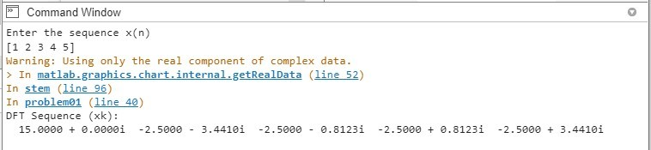

Fig 01: command line

# OUTPUT WAVEFORMS:

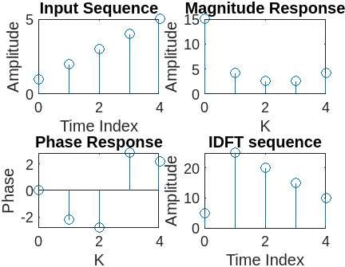

Fig 02: wavelengths

# Exercise:

1. Find 8-point DFT of the sequence x (n) = [1 2 3 4 4 3 2 1]

# Output:

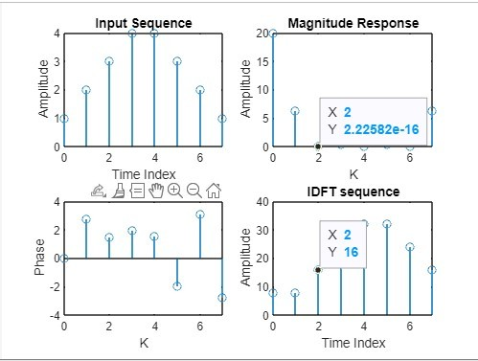

Fig 03: wavelength

# VIVA QUESTIONS:

### Define signal, Give Examples for 1-D, 2-D, 3-D signals.

A signal is a function that conveys information. It can be a physical quantity, such as sound or light, or it can be a mathematical function. Signals can be classified by the number of dimensions they have.

* + **1-D signals** are signals that have one dimension. Examples of 1-D signals include audio signals, time series data, and financial data.
  + **2-D signals** are signals that have two dimensions. Examples of 2-D signals include images and videos.
  + **3-D signals** are signals that have three dimensions. Examples of 3-D signals include medical images and volumetric data.

### Define transform. What is the need for transformation?

A transform is a mathematical operation that converts a signal from one domain to another. The original domain is called the time domain, and the new domain is called the frequency domain. The need for transformation is to make it easier to analyze and process signals.

In the time domain, a signal is represented as a sequence of values. This can be difficult to analyze, especially for signals that are long or complex. In the frequency domain, a signal is represented as a sequence of frequencies. This makes it easier to see the different frequencies that make up the signal, and it can also be used to filter out unwanted frequencies.

### Differentiate Fourier transform and discrete Fourier transform.

Fourier transform is a means of mapping a signal, in the time or space domain into its spectrum in the frequency domain. The time and frequency domains are just alternative ways of representing signals and the Fourier transform is the mathematical relationship between the two representations. A change of signaling in one domain would also affect the signal in the other domain, but not necessarily in the same way.

Discrete Fourier Transform transforms like Fourier transforms are used with digitized signals. As the name suggests, it is the discrete vers of the FT that views the bother me domain and frequency domain as periodic. Fast Fourier Transform is just an algorithm for fast and efficient computer of the DFT.

### Differentiate DFT and DTFT

The DFT and the DTFT are both discrete-time transforms, but there are some key differences between them. The DFT is a finite-length transform, while the DTFT is an infinite-length transform. This means that the DFT can only be used to analyze signals that are finite in length, while the DTFT can be used to analyze signals that are infinite in length.

The DFT is also a periodic transform, while the DTFT is a non-periodic transform. This means that the DFT of a signal is periodic, while the DTFT of a signal is not periodic.

### Explain mathematical formula for calculation of DFT.

The mathematical formula for calculating the DFT of a signal is as follows:

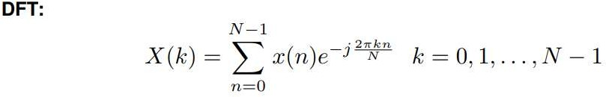

where:

* + x[k] is the kth sample of the signal
  + N is the number of samples in the signal
  + j is the imaginary unit
  + 2π is a constant

### Explain mathematical formula for calculation of IDFT.

The mathematical formula for calculating the IDFT of a signal is as follows:

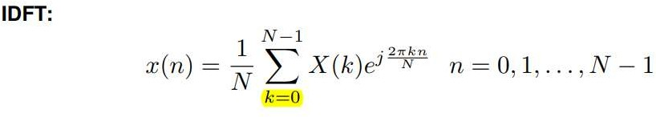

where:

* + X[k] is the kth sample of the DFT
  + N is the number of samples in the DFT
  + j is the imaginary unit
  + 2π is a constant

### How to calculate FT for 1-D signal?

To calculate the FT of a 1-D signal, you can use the following steps:

1. Pad the signal with zeros to make it a multiple of 2. This is necessary because the DFT is only defined for signals that are a multiple of 2.
2. Calculate the DFT of the padded signal.
3. Discard the first half of the DFT coefficients. These coefficients are redundant.
4. The remaining coefficients are the FT coefficients of the original signal.

### What is meant by magnitude plot, phase plot, power spectrum?

* + **Magnitude plo**t is a plot of the magnitude of the Fourier transform of a signal. The magnitude of the Fourier transform is a measure of the energy present in the signal at each frequency. A higher magnitude at a particular frequency indicates that more energy is present in the signal at that frequency.
  + **Phase plot** is a plot of the phase of the Fourier transform of a signal. The phase of the Fourier transform is a measure of the shift in the phase of the signal at each frequency. A positive phase indicates that the signal is delayed at that frequency, while a negative phase indicates that the signal is advanced at that frequency.
  + **Power spectrum** is a plot of the power of the Fourier transform of a signal. The power of the Fourier transform is a measure of the squared magnitude of the Fourier transform. A higher power at a particular frequency indicates that more energy is present in the signal at that frequency.

### Explain the applications of DFT.

The DFT has a wide range of applications in signal processing, image processing, and other areas. Some of the most common applications of the DFT include:

* + **Signal analysis**: By using the DFT to analyse signals in the frequency domain, it is possible to determine the frequencies that a signal contains.
  + **Image processing:** By analyzing images in the frequency domain with the DFT, it is possible to determine the frequencies that an image contains. This data can be utilised to enhance specific aspects of the image or to filter out undesired frequencies.
  + **Digital filtering**: Digital filters can be created using the DFT. A mathematical function called a digital filter can be used to exclude undesirable frequencies from a signal.
  + **Convolution:** The DFT can be used to compute the convolution of two signals. Convolution is a mathematical operation that is used to combine two signals. The DFT can be used to compute the convolution of two signals efficiently.

### What are separable transforms?

A separable transform is one that may be divided into two or more one-dimensional transforms and produced as a product. The two-dimensional DFT, for instance, can be broken down into a product of two one-dimensional DFTs.

* + **Two-dimensional DFT:** The two-dimensional DFT can be decomposed into a product of two one-dimensional DFTs.
  + **Three-dimensional DFT:** The three-dimensional DFT can be decomposed into a product of three one-dimensional DFTs.
  + **Wavelet transform:** The wavelet transform is a separable transform that can be used to decompose a signal into a set of wavelets.

# DISCUSSION:

In the discussion, we observed the successful conversion of a discrete-time signal into its frequency domain representation using the Discrete Fourier Transform (DFT). The DFT analysis allowed us to identify the various frequency components present in the original signal, providing valuable insights into its spectral characteristics. We examined the magnitudes and phases of the DFT coefficients, which revealed dominant frequencies and their corresponding amplitudes.

Furthermore, we applied the Inverse Discrete Fourier Transform (IDFT) to transform the frequency domain representation back to the time domain. The reconstructed signal closely matched the original input, confirming the accuracy of the IDFT calculations and the reversibility of the transformation.

# CONCLUSION:

The experiment to find the Discrete Fourier Transform (DFT) and Inverse Discrete Fourier Transform (IDFT) of a given DT signal was successfully conducted. Through this experiment, we gained a deeper understanding of how signals can be transformed between the time and frequency domains.

The DFT analysis revealed the frequency components present in the given discrete-time signal, providing valuable insights into its spectral content. By examining the magnitude and phase of the DFT coefficients, we identified the dominant frequencies and their corresponding amplitudes.

# Reference:

1. https://www.geeksforgeeks.org/discrete-fourier-transform-and-its-inverse-using-matlab/ [Accessed 28 July 2023,10:00pm]
2. https://www.tutorialspoint.com/digital_signal_processing/dsp_discrete_fourier_transform_inroduction.htm [Accessed 28 July 2023,1:00pm]